Kids Cooking Local Foods Classes
Scholarship Form Application
***Deadline is July 27 to the OSU Extension Ofﬁce***

Scholarships are available for families who ﬁnd that the cost of the classes may prevent their child(ren) from participating. This is thanks to the kind and generous support of a local foods enthusiast who strongly believes in equipping young people with life skills and appreciation of community.

We ask that you only apply for this scholarship if cost completely prohibits your child(ren) from participating.

Child’s name
Age

Parent/Guardian’s Name

Do you have more than one child in your family who would like to participate?

Yes
No

If yes, name of other child(ren) _______________________________________________________

What are you hoping your child(ren) will learn from this experience?
___________________________________________________________________________________
___________________________________________________________________________________
___________________________________________________________________________________

Please brieﬂy explain why you should be considered for this assistance.
___________________________________________________________________________________
___________________________________________________________________________________
___________________________________________________________________________________
___________________________________________________________________________________

Name of Parent or Guardian

Signature of Parent or Guardian

Phone number

Parent/Guardian will be notiﬁed by August 1 of the scholarship amount awarded.

Cooking camp will be Monday, August 8 through Friday, August 12. Classes are available at 10:00 a.m. (5-7 year olds) or 11:00 a.m. (8-10 year olds). These lessons are for children who want a hands-on cooking experience.
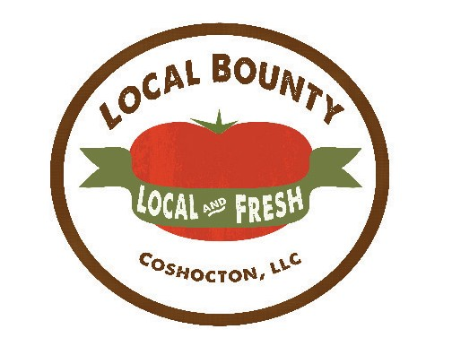

OSU EXTENSION COSHOCTON COUNTY

